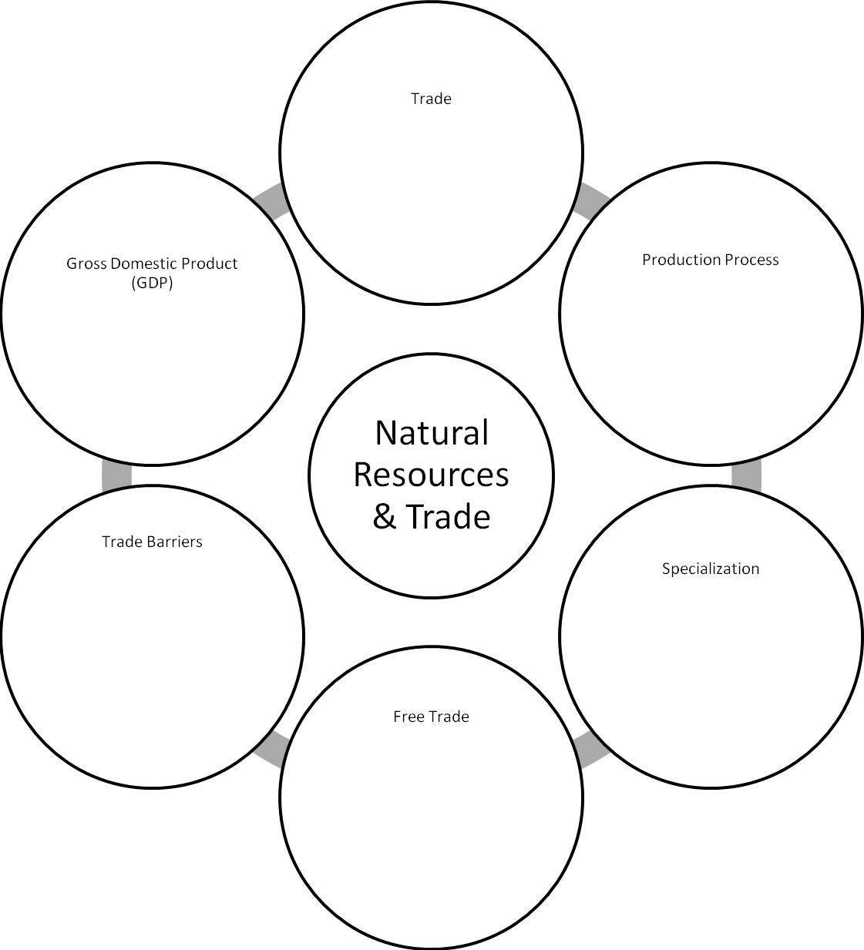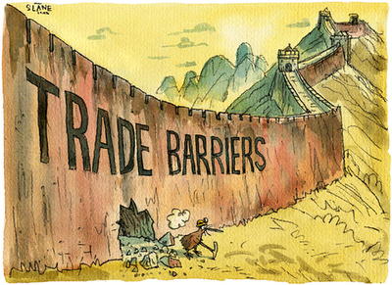

|  |  |
| --- | --- |
| **Barrier** | **Definition** |
| Tariff |  |
| Quota |  |
| Embargo |  |

Give an example of a trade barrier that is currently in place and the countries involved.

Do you think there should be free trade or trade barriers between countries? Explain your answer.